**Web Programming Lab**

**Register Number:** 23BCE1777

**Name:** Madamsetty Sai Venkat Akshat

**Subject Code:** BCSE203E

**Subject Name:** Web Programming Lab

**Slot:** TE1/TE2

**Exercise-14**

**Question1:**

**Code:(App.js)**

import React from "react";

import srcImage from "./images/beru.png";

function App() {

  return (

    <div style={{ textAlign: "center", padding: "20px" }}>

      <h1>Displaying Images in React</h1>

      {/* Image from public folder (Use relative path) */}

      <h2>Image from public folder</h2>

      <img src={`${process.env.PUBLIC_URL}/images/igris.png`} alt="Public Folder Image" width="300" />

      {/* Image from src folder (Must be imported) */}

      <h2>Image from src folder</h2>

      <img src={srcImage} alt="Src Folder Image" width="300" />

    </div>

  );

}

export default App;

**Output:**

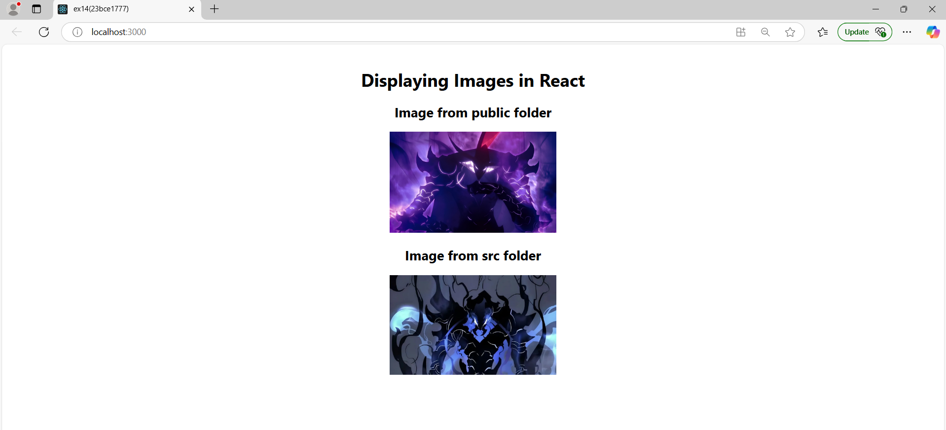

**Question-2:**

**Code:**

import React, { useState } from "react";

function NovellLoginForm() {

  const [formData, setFormData] = useState({

    username: "",

    password: "",

    city: "",

    server: "",

    role: "",

    signOn: [],

  });

  const handleChange = (e) => {

    const { name, value, type, checked } = e.target;

    if (type === "checkbox") {

      setFormData((prevData) => ({

        ...prevData,

        signOn: checked

          ? [...prevData.signOn, value]

          : prevData.signOn.filter((item) => item !== value),

      }));

    } else {

      setFormData({ ...formData, [name]: value });

    }

  };

  const handleSubmit = (e) => {

    e.preventDefault();

    console.log("Submitted Data:", formData);

  };

  const handleReset = () => {

    setFormData({

      username: "",

      password: "",

      city: "",

      server: "",

      role: "",

      signOn: [],

    });

  };

  return (

    <div style={styles.container}>

      <h2 style={styles.heading}>Novell Services Login</h2>

      <form onSubmit={handleSubmit}>

        {/* Username */}

        <div style={styles.inputGroup}>

          <label>Username:</label>

          <input type="text" name="username" value={formData.username} onChange={handleChange} />

        </div>

        {/* Password */}

        <div style={styles.inputGroup}>

          <label>Password:</label>

          <input type="password" name="password" value={formData.password} onChange={handleChange} />

        </div>

        {/* City */}

        <div style={styles.inputGroup}>

          <label>City of Employment:</label>

          <input type="text" name="city" value={formData.city} onChange={handleChange} />

        </div>

        {/* Web Server Dropdown */}

        <div style={styles.inputGroup}>

          <label>Web server:</label>

          <select name="server" value={formData.server} onChange={handleChange}>

            <option value="">-- Choose a server --</option>

            <option value="Server 1">Server 1</option>

            <option value="Server 2">Server 2</option>

            <option value="Server 3">Server 3</option>

          </select>

        </div>

        {/* Role Selection (Radio Buttons) */}

        <div style={styles.inputGroup}>

          <label>Please specify your role:</label>

          <div style={styles.radioContainer}>

            {["Admin", "Engineer", "Manager", "Guest"].map((role) => (

              <label key={role} style={styles.radioLabel}>

                <input type="radio" name="role" value={role} checked={formData.role === role} onChange={handleChange} />

                {role}

              </label>

            ))}

          </div>

        </div>

        {/* Single Sign-On (Checkboxes) */}

        <div style={styles.inputGroup}>

          <label>Single Sign-on to the following:</label>

          <div style={styles.radioContainer}>

            {["Mail", "Payroll", "Self-service"].map((service) => (

              <label key={service} style={styles.radioLabel}>

                <input type="checkbox" name="signOn" value={service} checked={formData.signOn.includes(service)} onChange={handleChange} />

                {service}

              </label>

            ))}

          </div>

        </div>

        {/* Buttons */}

        <div style={styles.buttonGroup}>

          <button type="submit">Login</button>

          <button type="button" onClick={handleReset}>Reset</button>

        </div>

      </form>

    </div>

  );

}

// CSS Styles for 50-50 Layout

const styles = {

  container: {

    width: "450px",

    margin: "auto",

    padding: "20px",

    border: "1px solid #ccc",

    borderRadius: "10px",

    fontFamily: "Arial, sans-serif",

    backgroundColor: "#f9f9f9",

  },

  heading: {

    textAlign: "center",

    marginBottom: "15px",

  },

  inputGroup: {

    display: "flex",

    alignItems: "center",

    justifyContent: "space-between",

    marginBottom: "10px",

  },

  radioContainer: {

    display: "flex",

    flexWrap: "wrap",

    justifyContent: "flex-start",

    gap: "10px",

  },

  radioLabel: {

    display: "flex",

    alignItems: "center",

    gap: "5px",

  },

  buttonGroup: {

    display: "flex",

    justifyContent: "space-between",

    marginTop: "10px",

  },

};

export default NovellLoginForm;

**Output:**

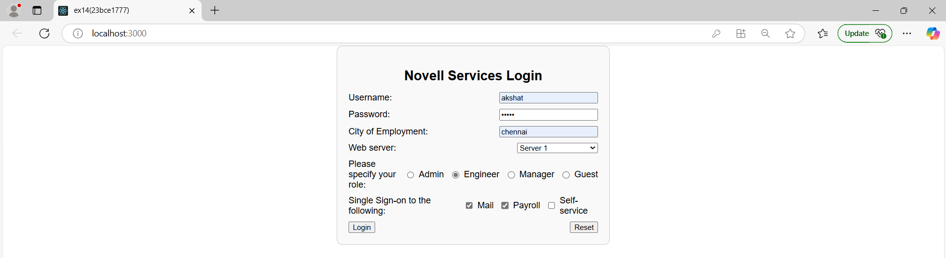

**Question-3:**

**ProfileImage.js**

import React from "react";

const ProfileImage = () => {

  return (

    <div>

      <img

        src={`${process.env.PUBLIC_URL}/passport.jpg`} // Access image from public folder

        alt="User Profile"

        style={{ width: "150px", borderRadius: "50%" }}

      />

    </div>

  );

};

export default ProfileImage;

**UserInfo.js**

import React from "react";

const UserInfo = ({ name, email, bio }) => {

  return (

    <div style={styles.infoContainer}>

      <h2 style={styles.name}>{name}</h2>

      <p><strong>Email:</strong> {email}</p>

      <p><strong>Bio:</strong> {bio}</p>

    </div>

  );

};

const styles = {

  infoContainer: {

    marginTop: "10px",

  },

  name: {

    fontSize: "20px",

    fontWeight: "bold",

    color: "#333",

  },

};

export default UserInfo;

**Userposts.js**

import React from "react";

const UserPosts = ({ posts }) => {

  return (

    <div style={styles.postContainer}>

      <h3 style={styles.heading}>User Posts</h3>

      <ul style={styles.list}>

        {posts.map((post, index) => (

          <li key={index} style={styles.postItem}>{post}</li>

        ))}

      </ul>

    </div>

  );

};

const styles = {

  postContainer: {

    marginTop: "15px",

  },

  heading: {

    fontSize: "16px",

    fontWeight: "bold",

    color: "#007bff",

  },

  list: {

    listStyleType: "none",

    padding: 0,

  },

  postItem: {

    background: "#f1f1f1",

    padding: "8px",

    marginTop: "5px",

    borderRadius: "5px",

  },

};

export default UserPosts;

**ProfilePage.js**

import React from "react";

import ProfileImage from "./ProfileImage";

import UserInfo from "./UserInfo";

import UserPosts from "./UserPosts";

const ProfilePage = () => {

  const user = {

    name: "Akshat MSV",

    email: "saiakshat@gmail.com",

    bio: "Web Developer | React Enthusiast",

    imageUrl: `${process.env.PUBLIC_URL}/passport.jpg`,

    posts: ["First post!", "Loving React!", "Coding is fun!"]

  };

  return (

    <div style={styles.container}>

      <div style={styles.card}>

        <ProfileImage imageUrl={user.imageUrl} />

        <UserInfo name={user.name} email={user.email} bio={user.bio} />

        <UserPosts posts={user.posts} />

      </div>

    </div>

  );

};

const styles = {

  container: {

    display: "flex",

    justifyContent: "center",

    alignItems: "center",

    minHeight: "100vh",

    backgroundColor: "#f8f9fa",

  },

  card: {

    width: "350px",

    backgroundColor: "#fff",

    padding: "20px",

    borderRadius: "12px",

    boxShadow: "0 4px 8px rgba(0, 0, 0, 0.1)",

    textAlign: "center",

  }

};

export default ProfilePage;

**Output:**

